Business Intelligence Lab Unit 1 | Session 3
Experiment 3
Dimensional Modeling and Star Schema Design using Microsoft Power BI

Aim
To design and implement a dimensional data model using Microsoft Power BI by transforming transactional data from the Global Superstore dataset into a Star Schema consisting of Fact and Dimension tables for efficient reporting and analytical processing.

Tools / Software Required
1. Microsoft Power BI Desktop
2. Global Superstore Dataset.xlsx
3. Power Query Editor
4. DAX (Data Analysis Expressions)
Dataset Source:
Global Superstore Dataset (Kaggle)
https://www.kaggle.com/datasets/apoorvaappz/global-super-store-dataset

Theory
Dimensional Modeling is a data warehouse design technique used in Business Intelligence systems to support analytical processing. It organizes data into Fact Tables and Dimension Tables.
Fact Tables contain measurable business events such as Sales, Profit, Quantity, and Discount.
Dimension Tables contain descriptive attributes such as Customer, Product, Region, and Date.
A Star Schema consists of a central Fact Table connected to multiple Dimension Tables. It improves query performance, simplifies reporting, and enhances scalability in BI environments.

Conduct - Part A: Load Dataset
Step 1: Open Power BI Desktop.
Step 2: Import Global Superstore Dataset.xlsx.
Step 3: Select Orders, Returns, and People worksheets.
Step 4: Click Load and verify imported tables.
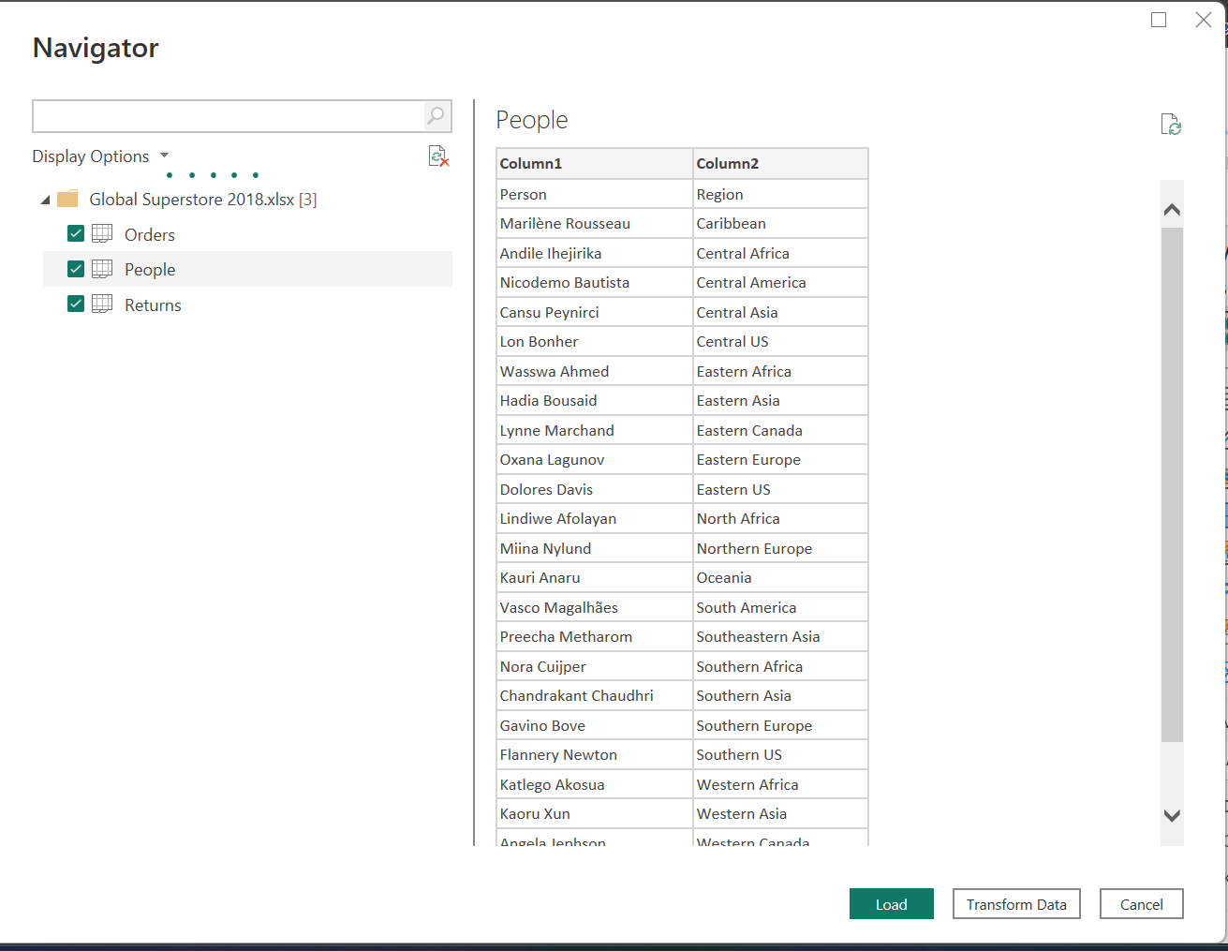

Conduct - Part B: Identify Fact and Dimension Tables
Step 5: Analyze Orders table and identify measures such as Sales, Profit, Quantity, and Discount.
Step 6: Identify descriptive attributes including Customer, Product, Region, and Date information.
Step 7: Categorize attributes into Fact and Dimension tables.

Conduct - Part C: Create Dimension Tables
Step 8: Create Dim_Customer using Customer ID, Customer Name, and Segment.
Step 9: Create Dim_Product using Product ID, Product Name, Category, and Sub-Category.
Step 10: Create Dim_Region using Region, Country, State, and City.
Step 11: Create Dim_Date using Order Date, Year, Quarter, and Month.
Step 12: Remove duplicate records from all dimensions.
Dim_Customer table
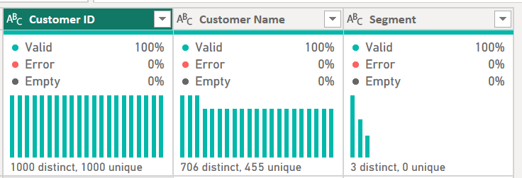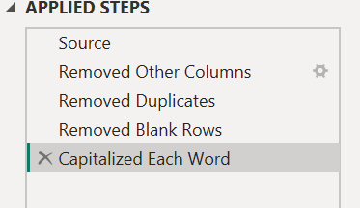
Dim_Product table
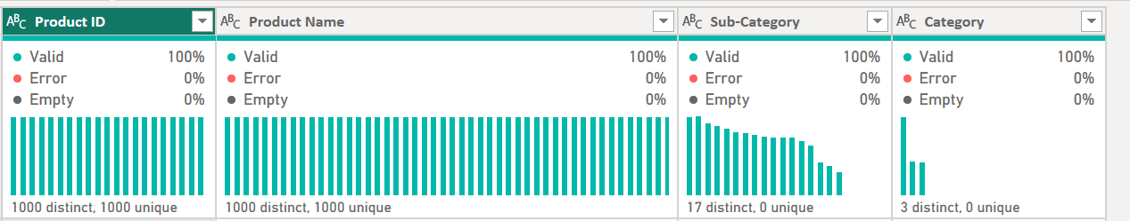
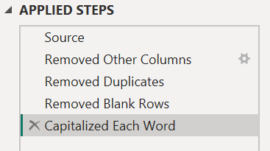
Dim_Region table
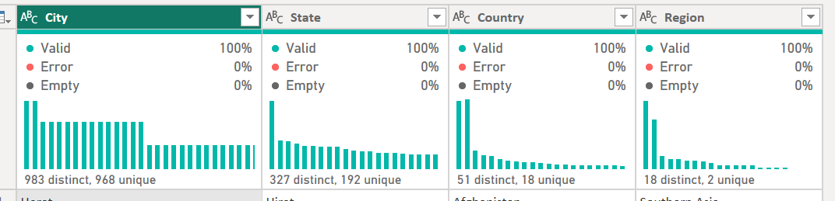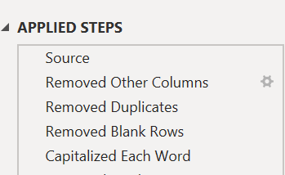
Dim_Date table
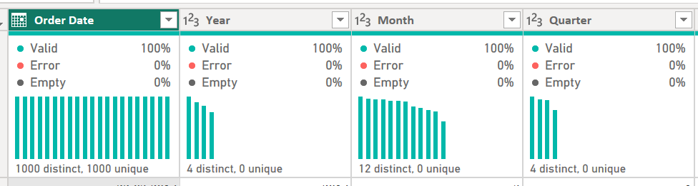
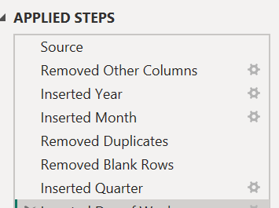

Conduct - Part D: Create Fact Table
Step 13: Create Fact_Sales containing Order ID, Customer ID, Product ID, Region, Order Date, Sales, Quantity, Profit, and Discount.
Step 14: Verify all key columns required for relationships.
Fact_Sales table
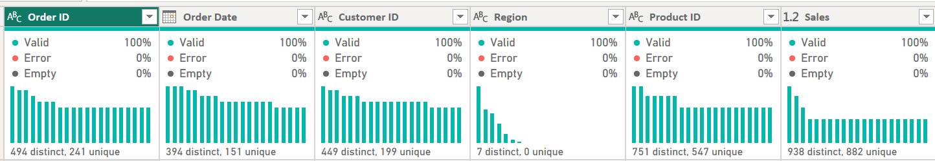
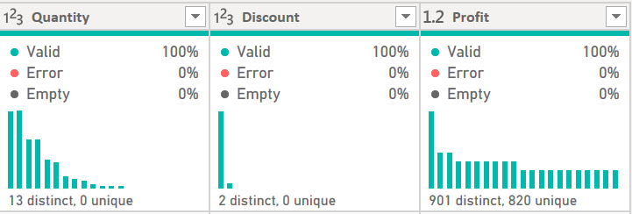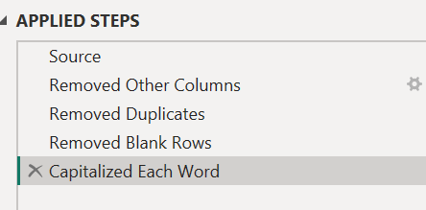

Conduct - Part E: Build Star Schema
Step 15: Open Model View.
Step 16: Create relationships between Fact_Sales and all Dimension Tables.
Step 17: Configure relationships as Many-to-One.
Step 18: Arrange tables visually into a Star Schema layout.
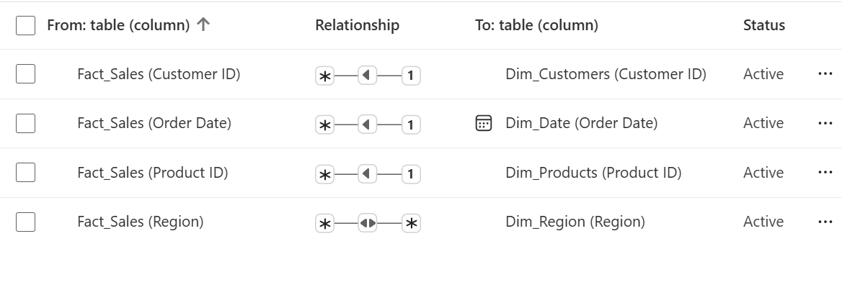
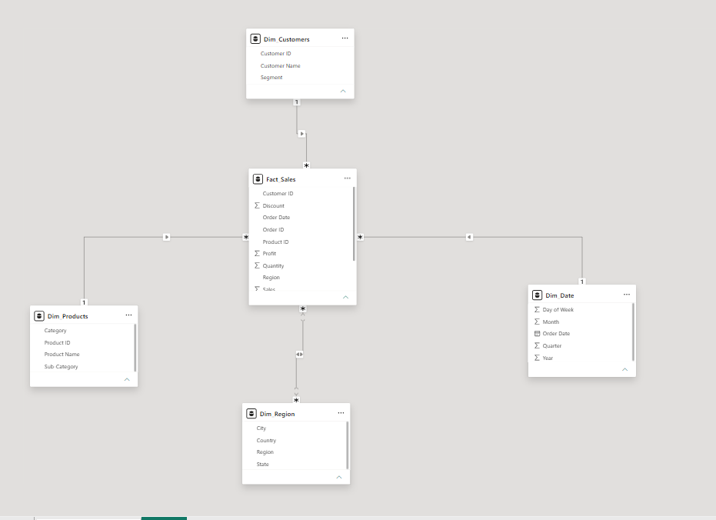

Conduct - Part F: Validate Model
Step 19: Create visualizations such as Sales by Category, Profit by Region, and Sales Trend by Year.
Step 20: Create DAX measures including Total Sales, Total Profit, Profit Margin, and Average Order Value.
Step 21: Verify that dimensions correctly filter fact data.
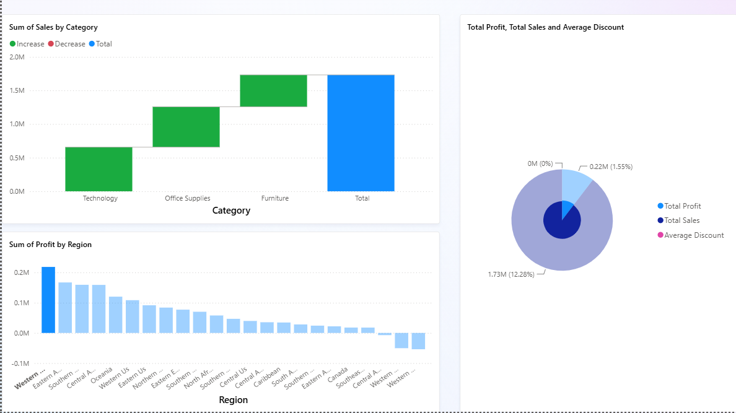

Result
A dimensional model was successfully designed and implemented using Microsoft Power BI. A Star Schema was created consisting of one Fact Table and multiple Dimension Tables. Relationships and DAX measures were successfully implemented and validated using reports.

Learning Outcomes
• Explain dimensional modeling concepts and Star Schema architecture.
• Differentiate between Fact and Dimension tables.
• Design dimensional models using real-world business datasets.
• Create and validate Star Schemas in Power BI.
• Develop DAX measures for analytical reporting.

